Muhammad Abdullah 19F-0916 Zainab Ijaz 19F-0917

SE (7A)

Applied Machine Learning

Class Task: Monty Hall Problem

**MONTY HALL PROBLEM USING DAG**

Code in Python:

import math  
from pomegranate import *  
  
guest = DiscreteDistribution({'A': 1. / 3, 'B': 1. / 3, 'C': 1. / 3})  
prize = DiscreteDistribution({'A': 1. / 3, 'B': 1. / 3, 'C': 1. / 3})  
monty = ConditionalProbabilityTable(  
 [['A', 'A', 'A', 0.0],  
 ['A', 'A', 'B', 0.5],  
 ['A', 'A', 'C', 0.5],  
 ['A', 'B', 'A', 0.0],  
 ['A', 'B', 'B', 0.0],  
 ['A', 'B', 'C', 1.0],  
 ['A', 'C', 'A', 0.0],  
 ['A', 'C', 'B', 1.0],  
 ['A', 'C', 'C', 0.0],  
 ['B', 'A', 'A', 0.0],  
 ['B', 'A', 'B', 0.0],  
 ['B', 'A', 'C', 1.0],  
 ['B', 'B', 'A', 0.5],  
 ['B', 'B', 'B', 0.0],  
 ['B', 'B', 'C', 0.5],  
 ['B', 'C', 'A', 1.0],  
 ['B', 'C', 'B', 0.0],  
 ['B', 'C', 'C', 0.0],  
 ['C', 'A', 'A', 0.0],  
 ['C', 'A', 'B', 1.0],  
 ['C', 'A', 'C', 0.0],  
 ['C', 'B', 'A', 1.0],  
 ['C', 'B', 'B', 0.0],  
 ['C', 'B', 'C', 0.0],  
 ['C', 'C', 'A', 0.5],  
 ['C', 'C', 'B', 0.5],  
 ['C', 'C', 'C', 0.0]],  
 [guest, prize])  
  
d1 = State(guest, name="guest")  
d2 = State(prize, name="prize")  
d3 = State(monty, name="monty")  
  
network = BayesianNetwork("Solving the Monty Hall Problem With DAG")  
network.add_states(d1, d2, d3)  
network.add_edge(d1, d3)  
network.add_edge(d2, d3)  
network.bake()

Test Data Set Used:

1.

beliefs = network.predict_proba({ 'guest' : 'A' })  
beliefs = map(str, beliefs)  
print("n".join( "{}t{}".format( state.name, belief ) for state, belief in zip( network.states, beliefs ) ))

2.

beliefs = network.predict_proba({'guest' : 'A', 'monty' : 'B'})  
print("n".join( "{}t{}".format( state.name, str(belief) ) for state, belief in zip( network.states, beliefs )))

Output:

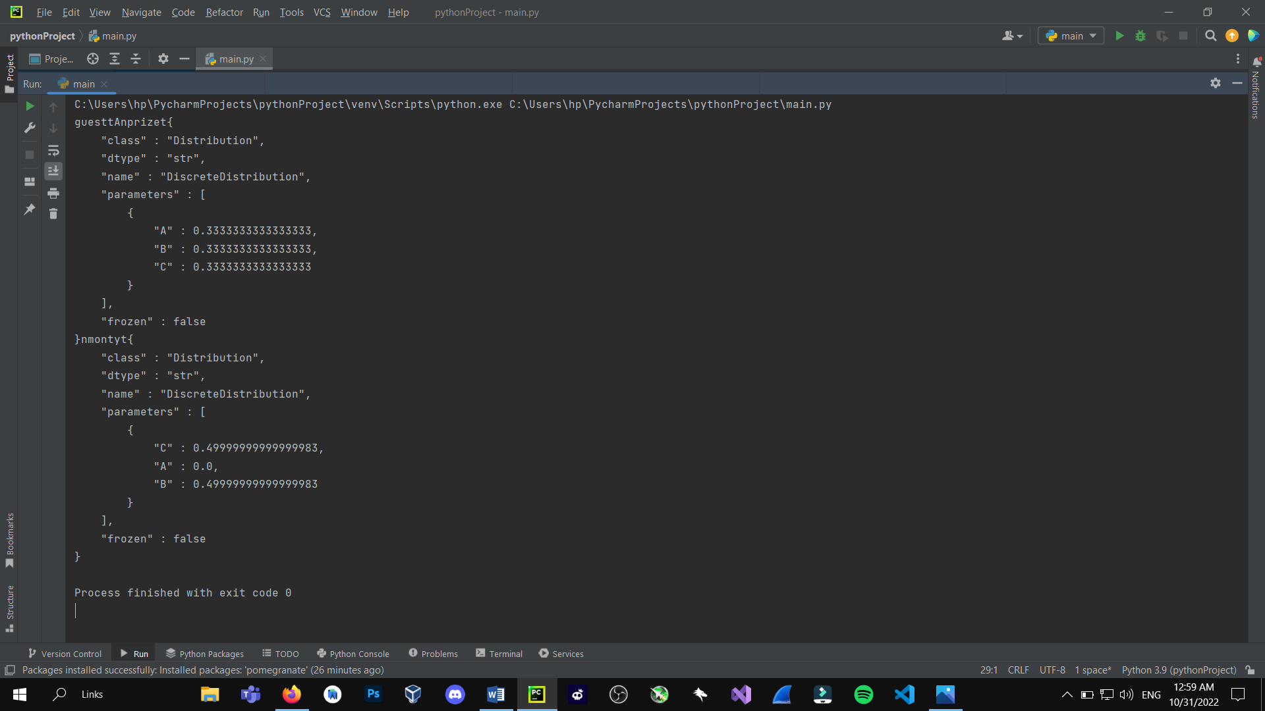

**Another Way (User Input):**

import random, os, sys  
from random import choice  
  
doors = ["A", "B", "C"]  
car_in = random.choice(doors)  
  
remaining_doors = doors  
  
while True:  
 print("Welcome to the Monty Hall Problem!\n")  
 print("First choice:")  
 choice1 = input("Door A: ?\nDoor B: ?\nDoor C: ?\nChoose a door\n>>> ").upper()  
  
 if choice1.upper() == "A" or choice1.upper() == "B" or choice1.upper() == "C":  
 pass  
 else:  
 break  
  
 if choice1 == car_in:  
  
 remaining_doors.remove(car_in)  
 print("Remaining doors: " + str(remaining_doors))  
 open_door = random.choice(remaining_doors)  
 last_door = remaining_doors  
 last_door.remove(open_door)  
  
 last_door_format = "x"  
  
 if "A" in last_door:  
 last_door_format = "A"  
 elif "B" in last_door:  
 last_door_format = "B"  
 elif "C" in last_door:  
 last_door_format = "C"  
  
 print()  
  
 print("The host opens a door: " + str(open_door))  
 print("Door " + str(choice1) + ": ? (your 1st pick)\nDoor " + str(open_door) + ": goat\nDoor " + str(  
 last_door_format) + ": ?\n")  
 while True:  
  
 print("Second choice:")  
 choice2 = input("\nSwitch to door " + str(last_door_format) + " or stay on door " + str(  
 choice1) + "? [Switch/Stay]\n>>> ")  
  
 if choice2.lower() == "switch":  
 print("You've switched from door " + str(choice1) + " to door " + str(last_door_format))  
 print()  
 print()  
 print("Sorry, but the car was in door " + str(car_in) + "!")  
 print()  
 print("""  
Door {car_in}: Car  
Door {open_door}: Goat   
Door {last_door_format}: Goat   
 """.format(car_in=car_in, open_door=open_door, last_door_format=last_door_format))  
  
 input("")  
 sys.exit()  
  
 elif choice2.lower() == "stay":  
 print("You've stayed at door " + str(choice1))  
 print()  
 print()  
 print("Congratulations, you have won the car!")  
 print()  
 print("""  
Door {car_in}: Car  
Door {open_door}: Goat   
Door {last_door_format}: Goat   
 """.format(car_in=car_in, open_door=open_door, last_door_format=last_door_format))  
  
 input("")  
 sys.exit()  
  
 else:  
 print("error")  
 sys.exit()  
  
  
  
 else:  
  
 def doors_format():  
 global remaining_doors_format  
 remaining_doors_format = "X"  
  
 if "A" in remaining_doors:  
 remaining_doors_format = "A"  
 if "B" in remaining_doors:  
 remaining_doors_format = "B"  
 if "C" in remaining_doors:  
 remaining_doors_format = "C"  
  
  
 print()  
 print()  
 if choice1 == "A":  
 remaining_doors.remove("A")  
 # print("Remaining doors: "+str(remaining_doors))  
 remaining_doors.remove(car_in)  
 doors_format()  
 print("Door that is opened (revealing a goat): " + str(remaining_doors_format))  
  
 # print("remaining door"+str(remaining_doors))  
  
 print("Door " + str(choice1) + ": ? (your 1st pick)\nDoor " + str(  
 remaining_doors_format) + ": goat\nDoor " + str(car_in) + ": ?\n")  
  
  
 elif choice1 == "B":  
 remaining_doors.remove("B")  
 # print("Remaining doors: "+str(remaining_doors))  
 remaining_doors.remove(car_in)  
 doors_format()  
 print("Door that is opened (revealing a goat): " + str(remaining_doors_format))  
  
 print("Door " + str(choice1) + ": ? (your 1st pick)\nDoor " + str(  
 remaining_doors_format) + ": goat\nDoor " + str(car_in) + ": ?\n")  
  
  
  
  
  
 elif choice1 == "C":  
 remaining_doors.remove("C")  
 # print("Remaining doors: "+str(remaining_doors))  
 remaining_doors.remove(car_in)  
 doors_format()  
 print("Door that is opened (revealing a goat): " + str(remaining_doors_format))  
  
 print("Door " + str(choice1) + ": ? (your 1st pick)\nDoor " + str(  
 remaining_doors_format) + ": goat\nDoor " + str(car_in) + ": ?\n")  
  
 print()  
 print("Second choice:")  
 print()  
 print("Switch to door " + car_in + " or stay on door " + choice1 + "? [Switch/Stay]")  
 choice2 = input(">>> ")  
  
 if choice2.lower() == "stay":  
 print("You've stayed at door " + choice1)  
 print()  
 print()  
 print("Sorry, but the car was in door " + str(car_in) + "!")  
 print()  
 print("""  
Door {car_in}: Car  
Door {choice1}: Goat   
Door {remaining_doors_format}: Goat   
 """.format(car_in=car_in, choice1=choice1, remaining_doors_format=remaining_doors_format))  
  
 input("")  
 sys.exit()  
  
 elif choice2.lower() == "switch":  
 print("You've switched from door " + choice1 + " to door " + car_in)  
 print()  
 print()  
 print("Congratulations, you have won the car!")  
 print()  
 print("""  
Door {car_in}: Car  
Door {choice1}: Goat   
Door {remaining_doors_format}: Goat   
 """.format(car_in=car_in, choice1=choice1, remaining_doors_format=remaining_doors_format))  
  
 input("")  
 sys.exit()  
  
 else:  
 print("error")  
 break

